Commodore: 23128 Adapter Passive Rev. 0

Module Description

Table of Contents

Introduction 1

Bank Selection 1

Dimensions 2

Sources for BASIC and KERNAL for the C16 2

Compatibility of EPROMs 3

Using parallel EEPROMs 4

Installation 5

Revision History 5

Rev. 0 5

# Introduction

This board serves for adapting an EPROM type 27C128, 27C256 or 27C512 to a 23128 ROM socket. This is useful for e.g. for the Commodore C16 Kernal or the Kernal/Basic ROM of the C64.

A 27C256 or 27C512 fits 32k or 64k, which the size of the 23128 ROM is 16k. The selected 16k bank can be configured with a jumper JP1. A set jumper is LOW, an open jumper is HIGH.

|  |  |  |  |
| --- | --- | --- | --- |
| **Signal** | **Pin** | **Pin** | **Signal** |
| A14 | 1 | 2 | GND |
| A15 | 3 | 4 | GND |
| +5V | 5 | 6 | n.c. |

Table 1: Jumper (JP1) for Bank Selection

n.c. is not connected. The purpose of the +5V pin is providing supply voltage to a micro controller or logic circuit for switching between the Kernals.

JP1 can be configured with solder bridges, a pin header and jumpers are not required for a fix configuration.

There are jumpers (JP2, JP4 and JP4) for the chip select of the 23128 on the bottom side of the board. These are configured correctly already, see the schematics for more information. Only one of those should be closed. They are for future use.

# Bank Selection

The desired KERNAL (or other binary content) is selected at JP1. For the pinout refer to Table 1. The jumper is installed (vertically) in a way, that it connects the address line with the GND potential.

|  |  |  |  |
| --- | --- | --- | --- |
| A15 | A14 | 16k Block | Addr. Offset |
| set | set | #0 | 0x0000 |
| set | open | #1 | 0x4000 |
| open | set | #2 | 0x8000 |
| open | open | #3 | 0xC000 |

Table 2: Selection of EPROM memory blocks

A set jumper corresponds to a LOW level (binary 0), an open jumper to a HIGH level. The EPROM Offset Address and the C16/C64 address must not be confused.

# Dimensions

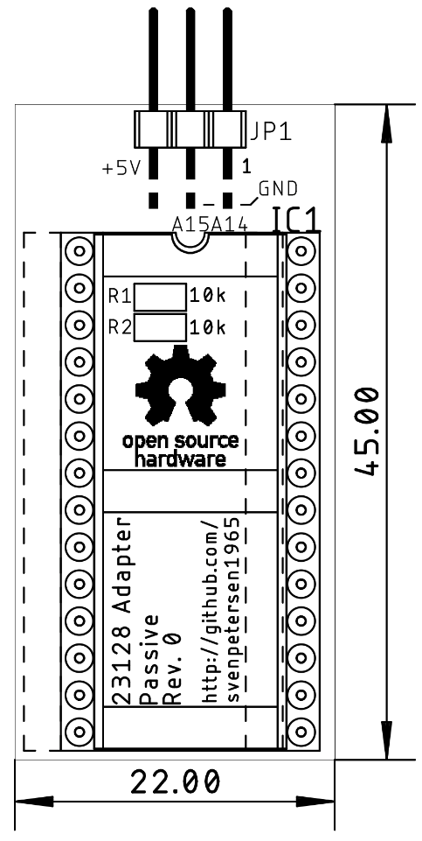

Figure 1: Dimensions

# Sources for BASIC and KERNAL for the C16

The content of the BASIC ROM (The BASIC ROM fits this adapter, too) and the KERNAL ROM can be found here:

[http://www.zimmers.net/anonftp/pub/cbm/firmware/computers/c64/index.html](http://www.zimmers.net/anonftp/pub/cbm/firmware/computers/plus4/index.html)

There are different Kernals for PAL and for NTSC machines. Be aware that you need the one, that fits your C16.

The popular JiffyDOS is still a commercial product and can be acquired for little money from

<http://www.go4retro.com/> or <https://restore-store.de/>

# Compatibility of EPROMs

It is recommended to use 27C512 EPROMs only. The smaller EPROM Types 27C256 and 27C128 might conflict with accessing the BASIC 8k slot. The unused address signals will be tied LOW while this access. This means, VPP will be approximately 0V and /PGM will be LOW. This is a not recommended setting.

|  |  |  |  |  |  |  |  |  |  |
| --- | --- | --- | --- | --- | --- | --- | --- | --- | --- |
| 27C128 | | | | | | | | | |
|  | 27C256 | | | | | | | |  |
|  | 27C512 | | | | | |  |
|  | SOCKET | | | |  |
| VPP | VPP | A15 | 1 | A15 | VCC | 28 | VCC | VCC | VCC |
| A12 | A12 | A12 | 2 | A12 | A14 | 27 | A14 | A14 | /PGM |
| A7 | A7 | A7 | 3 | A7 | A13 | 26 | A13 | A13 | A13 |
| A6 | A6 | A6 | 4 | A6 | A8 | 25 | A8 | A8 | A8 |
| A5 | A5 | A5 | 5 | A5 | A9 | 24 | A9 | A9 | A9 |
| A4 | A4 | A4 | 6 | A4 | A11 | 23 | A11 | A11 | A11 |
| A3 | A3 | A3 | 7 | A3 | /OE | 22 | /G/Vpp | /G | /G |
| A2 | A2 | A2 | 8 | A2 | A10 | 21 | A10 | A10 | A10 |
| A1 | A1 | A1 | 9 | A1 | GND | 20 | /E | /E | /E |
| A0 | A0 | A0 | 10 | A0 | D7 | 19 | D7 | D7 | D7 |
| D0 | D0 | D0 | 11 | D0 | D6 | 18 | D6 | D6 | D6 |
| D1 | D1 | D1 | 12 | D1 | D5 | 17 | D5 | D5 | D5 |
| D2 | D2 | D2 | 13 | D2 | D4 | 16 | D4 | D4 | D4 |
| GND | GND | GND | 14 | GND | D3 | 15 | D3 | D3 | D3 |

Table 3: EPROM pin compatibility

|  |  |  |  |
| --- | --- | --- | --- |
| EPROM | Size | A15 | A14 |
| 27C512 | 64kx8 | yes | yes |
| 27C256 | 32kx8 | HIGH | yes |
| 27C128 | 16kx8 | HIGH | HIGH |

Table 4: Settings per EPROM type

In case VPP is located at a dedicated pin (pin 1), A15 has no effect anymore. A HIGH level is recommended (switch is off). The /PGM Pin should be set HIGH. The n.c. (not connected) pin should be HIGH (with pull-up) or open.

# Using parallel EEPROMs

There are ***parallel*** EPROMs, which fit into the EPROM sockets. They do not require erasing with a UV eraser, like EPROMs, but the price is higher.

Since they can be written, which is controlled by the signal, but the Super Expander II cartridge is lacking of this functionality, this signal has to be HIGH (inactive). The 28C256 has the A14 signal connected to Pin 1, which is A15 of the EEPROM socket. This is no problem, but it has to be kept in mind, that the jumper for A15 has effect on the bank select A14 of the EPROM.

|  |  |  |  |  |  |
| --- | --- | --- | --- | --- | --- |
| 28C256 | | | | | |
|  | SOCKET | | | |  |
| 💣A14 | 1 | A15 | VCC | 28 | VCC |
| A12 | 2 | A12 | A14 | 27 | /WE |
| A7 | 3 | A7 | A13 | 26 | A13 |
| A6 | 4 | A6 | A8 | 25 | A8 |
| A5 | 5 | A5 | A9 | 24 | A9 |
| A4 | 6 | A4 | A11 | 23 | A11 |
| A3 | 7 | A3 | /OE | 22 | /G/Vpp |
| A2 | 8 | A2 | A10 | 21 | A10 |
| A1 | 9 | A1 | GND | 20 | /E |
| A0 | 10 | A0 | D7 | 19 | D7 |
| D0 | 11 | D0 | D6 | 18 | D6 |
| D1 | 12 | D1 | D5 | 17 | D5 |
| D2 | 13 | D2 | D4 | 16 | D4 |
| GND | 14 | GND | D3 | 15 | D3 |

Table 5: EEPROM pin compatibility

|  |  |  |  |
| --- | --- | --- | --- |
| EEPROM | Size | A15 | A14 |
| 28C256 | 32kx8 | =A14 | OPEN |

Table 6: Settings per EEPROM type

# Installation

The 23128 Adapter can be installed on a C64 short board (for BASIC and Kernal) or a C16 (C264 family) in the Kernal socket (U4) or the BASIC socket (U3). The notch that marks the direction of the socket and on the EPROM have to point in the same direction.

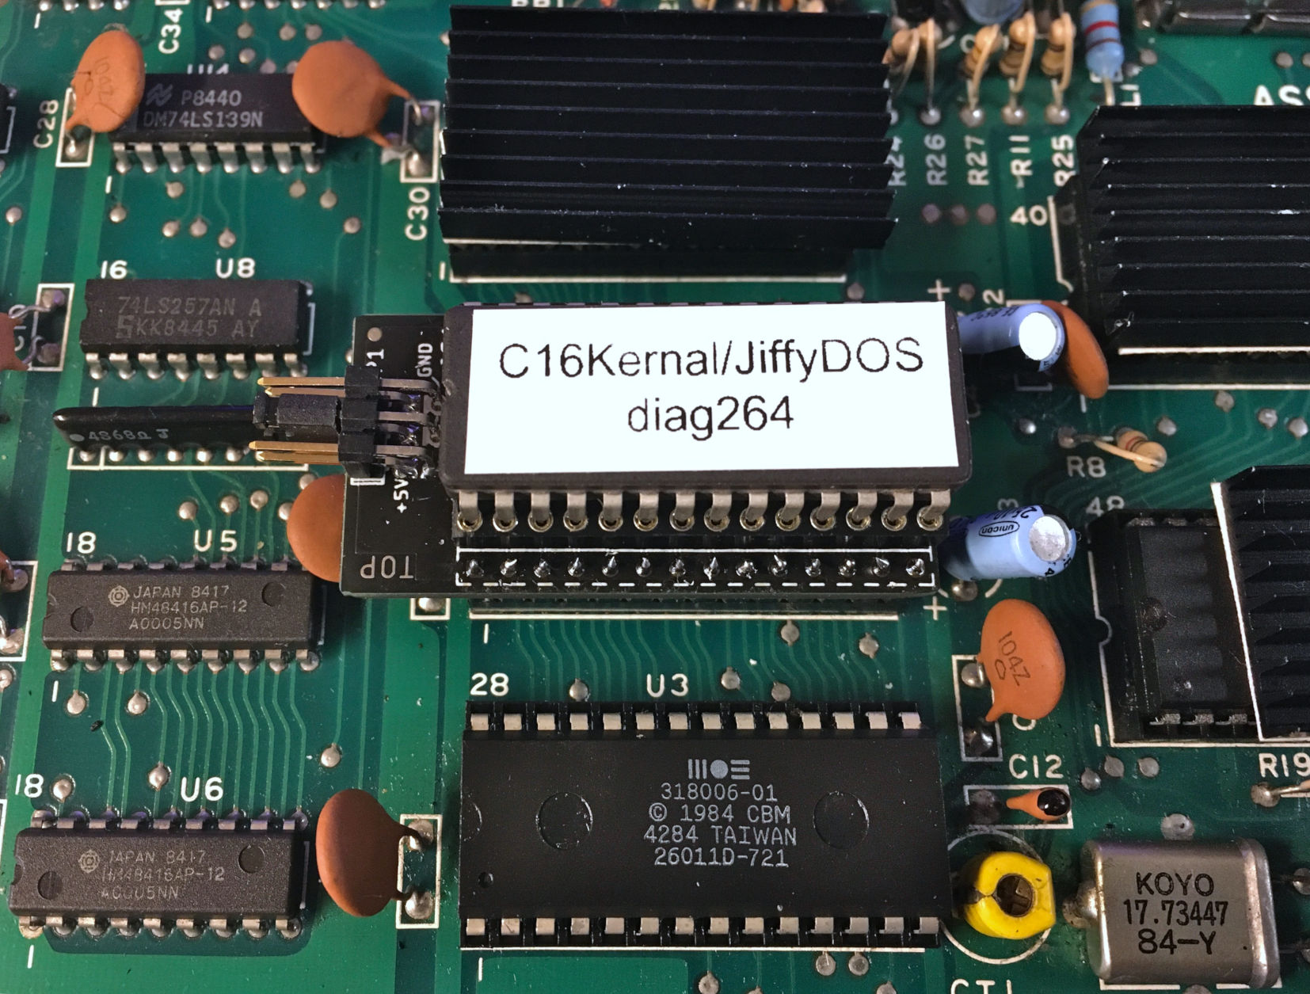

Figure 2: The 23128 Adapter installed in the U4 Kernals socket on a C16 board

# Revision History

## Rev. 0

* Fully functional prototype